**SONAR PREDICTION**

**1.1-INTRODUCTION**

Python is a programming language that lets you work quickly and integrate systems more effectively.The mission of the python software foundation is to promote, protect ,and advance the python programming language,and to support and facilitate the growth of a diverse and international community of python programmers.

**Why to use python?**

**1) Readable and Maintainable Code**

While writing a software application, you must focus on the quality of its source code to simplify maintenance and updates. The syntax rules of Python allow you to express concepts without writing additional code. At the same time, Python, unlike other programming languages, emphasizes on code readability, and allows you to use English keywords instead of punctuations. Hence, you can use Python to build custom applications without writing additional code. The readable and clean code base will help you to maintain and update the software without putting extra time and effort.

**2) Multiple Programming Paradigms**

Like other modern programming languages, Python also supports several programming paradigm. It supports object oriented and structured programming fully. Also, its language features support various concepts in functional and aspect-oriented programming. At the same time, Python also features a dynamic type system and automatic memory management. The programming paradigms and language features help you to use Python for developing large and complex software applications.

**3) Compatible with Major Platforms and Systems**

At present, Python is supports many operating systems. You can even use Python interpreters to run the code on specific platforms and tools. Also, Python is an interpreted programming language. It allows you to you to run the same code on multiple platforms without recompilation. Hence, you are not required to recompile the code after making any alteration. You can run the modified application code without recompiling and check the impact of changes made to the code immediately. The feature makes it easier for you to make changes to the code without increasing development time.

**4) Robust Standard Library**

Its large and robust standard library makes Python score over other programming languages. The standard library allows you to choose from a wide range of modules according to your precise needs. Each module further enables you to add functionality to the Python application without writing additional code. For instance, while writing a web application in Python, you can use specific modules to implement web services, perform string operations, manage operating system interface or work with internet protocols. You can even gather information about various modules by browsing through the Python Standard Library documentation.

**5) Many Open Source Frameworks and Tools**

As an open source programming language, Python helps you to curtail software development cost significantly. You can even use several open source Python frameworks, libraries and development tools to curtail development time without increasing development cost. You even have option to choose from a wide range of open source Python frameworks and development tools according to your precise needs. For instance, you can simplify and speedup web application development by using robust Python web frameworks like Django, Flask, Pyramid, Bottle and Cherrypy. Likewise, you can accelerate desktop GUI application development using [**Python GUI frameworks**](http://www.allaboutweb.biz/python-gui-frameworks-usage/)and toolkits like PyQT, PyJs, PyGUI, Kivy, PyGTK and WxPython.

**6) Simplify Complex Software Development**

Python is a general purpose programming language. Hence, you can use the programming language for developing both desktop and web applications. Also, you can use Python for developing complex scientific and numeric applications. Python is designed with features to facilitate data analysis and visualization. You can take advantage of the data analysis features of Python to create custom big data solutions without putting extra time and effort. At the same time, the data visualization libraries and APIs provided by Python help you to visualize and present data in a more appealing and effective way. Many [**Python developers**](http://www.mindfiresolutions.com/python-development.htm) even use Python to accomplish artificial intelligence (AI) and natural language processing tasks.

**7) Adopt Test Driven Development**

You can use Python to create prototype of the software application rapidly. Also, you can build the software application directly from the prototype simply by refactoring the Python code. Python even makes it easier for you to perform coding and testing simultaneously by adopting test driven development (TDD) approach. You can easily write the required tests before writing code and use the tests to assess the application code continuously. The tests can also be used for checking if the application meets predefined requirements based on its source code.

However, Python, like other programming languages, has its own shortcomings. It lacks some of the built-in features provided by other modern programming language. Hence, you have to use Python libraries, modules, and frameworks to accelerate custom software development. Also, several studies have shown that Python is slower than several widely used programming languages including Java and C++. You have to speed up the Python application by making changes to the application code or using custom runtime. But you can always use Python to speed up software development and simplify software maintenance.

**ARTIFICIAL INTELLIGENCE**

“The science and engineering of making intelligent machines, especially intelligent computer programs”. -John McCarthy-

Artificial Intelligence is an approach to make a computer, a robot, or a product to think how smart human think. AI is a study of how human brain think, learn, decide and work, when it tries to solve problems. And finally this study outputs intelligent software systems. The aim of AI is to improve computer functions which are related to human knowledge, for example, reasoning, learning, and problem-solving.

The intelligence is intangible. It is composed of

* Reasoning
* Learning
* Problem Solving
* Perception
* Linguistic Intelligence

The objectives of AI research are reasoning, knowledge representation, planning, learning, natural language processing, realization, and ability to move and manipulate objects. There are long-term goals in the general intelligence sector.

Approaches include statistical methods, computational intelligence, and traditional coding AI. During the AI research related to search and mathematical optimization, artificial neural networks and methods based on statistics, probability, and economics, we use many tools. Computer science attracts AI in the field of science, mathematics, psychology, linguistics, philosophy and so on.

**Applications of AI**

* Gaming − AI plays important role for machine to think of large number of possible positions based on deep knowledge in strategic games.
* For example, chess, river crossing, N-queens problems and etc.
* Natural Language Processing − Interact with the computer that understands natural language spoken by humans.
* Expert Systems − Machine or software provide explanation and advice to the users.
* Vision Systems − Systems understand, explain, and describe visual input on the computer.
* Speech Recognition − There are some AI based speech recognition systems have ability to hear and express as sentences and understand their meanings while a person talks to it.
* For example Siri and Google assistant.
* Handwriting Recognition − The handwriting recognition software reads the text written on paper and recognize the shapes of the letters and convert it into editable text.
* Intelligent Robots − Robots are able to perform the instructions given by a human.

**1.2 Objectives of Research**

Prediction for Underwater Sensing and Communications.

The name and setup suggests that the aim of this data is do distinguish between rocks and mines structure such as sea mines on the seafloor. The experimental setup was as follows:

* a metal cylinder and a cylindrical rock, both of length 5 ft, placed on sandy ocean floor
* sonar impulse: wide-band linear FM
* return sampling in a distance of 10 meters
* return sample aspect angle: spanning 90° (metal cylinder) and 180° (rock)
* input data is a normalized spectral envelope covering 60 samples (hence it is heavily pre-processed already and is not a time series but the result of one)
* 166 samples ; 69 metal samples, 97 rock samples

**1.3 Problem Statement**

To protect the sea vehicles from destructions we are using SONAR prediction**. I**t is a technique that uses sound propagation to navigate, communicate with or detect object on or under the surface of the water.

It is an echo-sounder with a directional capability that can show fish or other objects around the vessel.

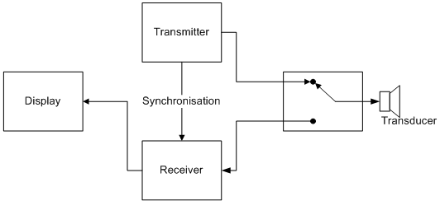

An electrical impulse is sent out from a transmitter which is converted into a sound wave by the transducer and sent into the water. When this sound wave hits an object it rebounds. This echo strikes the transducer which converts it into an electrical signal which is then amplified by the receiver and sent to the display screen. In most cases the same transducer is used for transmission as well as detection of sound waves.

Now the question arises as how to detect the source of the sound and to understand the distance of the object from the ship. A sonar system constitutes of several hydrophones which act as sensors, and once a sound wave hits the hydrophones, each one will record the intensity of the sound along with the phase. Phase is nothing but the delay in timing to receive the sound wave. The sensor which will record the highest amplitude and will have the least delay in timing will be considered to be placed nearest to the origin/point of reflection of the sound wave.

Another key factor which plays a crucial role in Sonar technology is the ocean environment. The performance of the sonar is highly dependent on the ocean environment which is highly unpredictable. Continued ocean studies for better understanding of the ocean are being pursued and better acoustic propagation models for accurate estimation of prediction ranges.

Scattering is one of the challenges which affect sonar technology. It is caused by small objects in the sea as well as from the bottom and surface. This proves to be a major source of interference. It is similar to scattering of light from a cars’ headlight in fog.

The sonar device measures how long it takes for the sound wave to travel down hit an object and then bounce back up. It’s the same echo-location system bats and dolphins use. This information enables the device to judge the depth of the object it reflected off. It also measures the strength of the returning pulse – the harder the objects, the stronger the return pulse.By these reflections we can know whether the object is Rock or Mine or any other vessel.

**2. REVIEW OF LITERATURE**

Ancient peoples have long used tubes as non-mechanical underwater listening devices to detect and transmit sound in [**water**](https://science.jrank.org/pages/7301/Water.html). In the later nineteenth century, scientists began to explore the physical properties associated with sound transmission in water.

The first Sonar devices were passive listening devices, meaning no signals were sent out. By 1918, both Britain and the U.S had built active systems (In active Sonar, signals are both sent out and then received back). Acoustic communication systems are Sonar devices where there is both a sound wave projector and receiver on both sides of the signal path. It was the invention of the acoustic transducer and efficient acoustic projectors that made more advanced forms of Sonar possible.

Improved [**electronics**](https://science.jrank.org/pages/2385/Electronics.html) and technology allowed the production of greatly improved listening and recording devices. Because passive SONAR is essentially nothing more than an elaborate recording and sound amplification device, these systems suffered because they were dependent upon the strength of the sound signal coming from the target. The signals or waves received could be typed (i.e. related to specific targets) for identifying characteristics. Although skilled and experienced operators could provide reasonably accurate estimates of range, bearing, and relative [**motion**](https://science.jrank.org/pages/4465/Motion.html) of targets, these estimates were far less precise and accurate than results obtained from active systems unless the targets were very close—or were very noisy.

**3. DATA COLLECTION**

### Sonar Technology

It is an acronym for Sound Navigation & Ranging (SONAR). Sonar is the technology of making use of sound waves to navigate, communicate and detect objects on or under surface of water. There are two types of Sonars today and they are:

### What is Sonar Technology?

**Active Sonar** – It emits an acoustic signal or pulse into the water and if an object is in the way of the acoustic pulse then the sound bounces back and returns an echo to the sonar transducer. The sonar transducer in turn measures the strength of the signal. By determining the time between the emission of the acoustic signal and its reception, the transducer is able to determine the orientation and range of the object.

**Passive Sonar**– It is essentially listening to the sound made by vessels. It is primarily used to detect noise from marine objects like submarines and marine animals like whales. Passive sonar does not emit its own signals; it only listens to the sound waves coming towards it. This comes to help for military vessels who do not want to be detected, like submarines.

**Applications:**

1. **Defence**: Most military vessels carry sonar systems which are used to detect and track enemy vessels, torpedos etc. Both active and passive sonars are used for military applications.
2. **Bathymetric Studies**:  Using multi beam sonars or echo sonars to determine the underwater depth of ocean floors has not only given accurate results in determining the depth of the sea floor, but has also made navigation safer over the years.
3. **Pipeline inspections**: Pipeline inspections can now be performed with high frequency side scan sonar which is used by oil & gas companies to detect spans, rock dump integrity & possible damage.
4. **Offshore wind turbines**: High resolution sonars are often used for installation of huge offshore wind turbines as potential sites need to be surveyed accurately. It is also used for checking the seabed and also scour protection around the foundation of the turbine.
5. **Detecting explosive dangers underwater**: As the seafloor gets increasingly exploited, it becomes equally important to identify objects before laying pipes, cables. Locating unexploded mines, bombs, torpedoes become increasingly important.
6. **Search and rescue missions**: Side scan sonar systems are being used by Search & Rescue teams. It is essentially used to locate the body and once the target of a body is located with the help of a side scan sonar it guides the diver to the site for recovering the body.
7. **Underwater Communications**: Dedicated sonars are fitted in ships and submarines for underwater communications.

**4. METHODOLOGY**

**4.1 Exploratory Data Analysis**

4.1.1 Figures and Tables

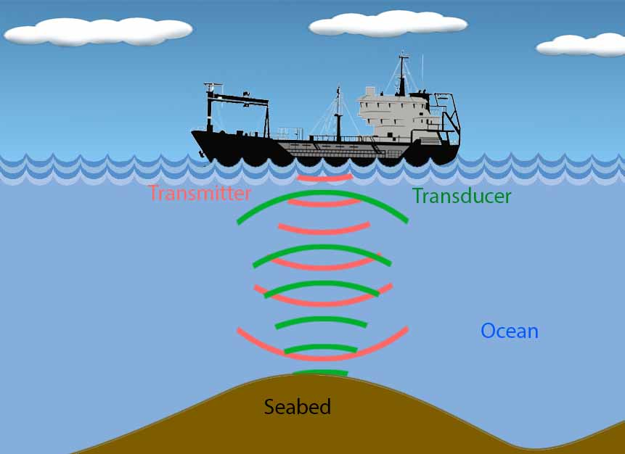

FIG:The above fig represents how the ships use SONAR to map sea beds.

Underwater surveillance implements which is known as passive Sonar — a technique that does not require its own transmitter, as it entails listening to sound waves emitted by other transmitters. This means listening to the sounds made by whales and enemy ships. The tool simply detects the sound waves that travel towards it. The machines, however, cannot determine the locations of these transmitters without the help of other passive listening devices. They work in conjunction to triangulate the location of a transmitter, stealthily, without making their presence felt.

Low-frequency sound waves, those below 20kHz, generate poor resolution, but they boast higher ranges, as they are highly unlikely to be attenuated by obstacles in between. On the contrary, high-frequency sound waves, those with a frequency greater than 100kHz, generate phenomenal resolution, but they are prone to heavy attenuation. A compromise emerges, such that the optimal frequency must be carefully selected in proportion to the size of the desired detail.As well as active sonar is shown below:

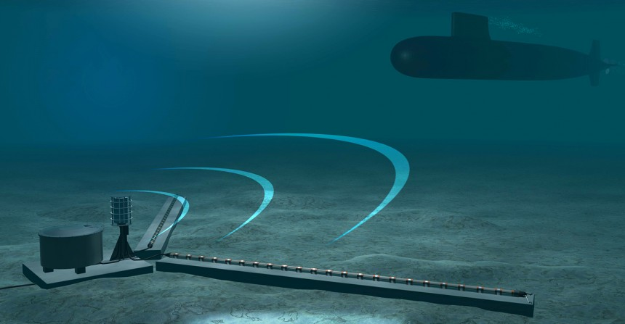

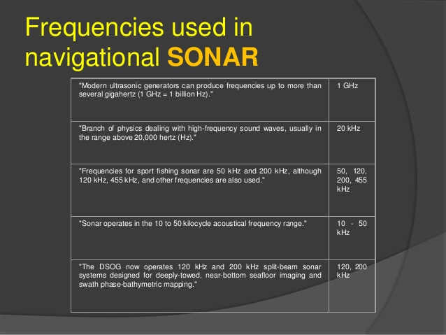

**4.2 Data Modelling**

We used artificial neural network interface for sonar prediction because we are getting better accuracy of about 99%.we compressed total 60 attributes into 6 attributes according to their band of frequencies .As we are not able to provide 60 attributes at the time of deploy using node-red so we compressed the data.

Now that you have a good idea about all the steps involved in this use case, let us go ahead and program the model using Tensorflow.

**1. Import all the required Libraries:**

At first, we will begin with all the required libraries as listed below:.

* **Tensor flow library:**It provides functions for implementing Deep Learning Model.
* **Keras library:** It used to build the model by adding Layers.
* **Pandas, numpy and sklearn library:**It provides functions for pre-processing the data.

**2. Read and Pre-process the data set**

In real-life use cases like SONAR, you will be provided with the raw data set which you need to read and pre-process so that you can train your model around it.

* At first we will read the CSV file (input data set) using read_csv () function.
* Now we can load the dataset using pandas and split the columns into 6 input variables(X) and 1 output variable(y).we use pandas to load the data because it easily handles strings (the output variables),whereas attempting to load the data directly using Numpy would be more difficult.
* Then, we will segregate the feature columns (independent variables) and the output column (dependent variable) as X and y respectively
* The output column consists of string categorical values as ‘R’ and ‘M’, signifying Rock and Mine respectively

So, we will label them as 0 and 1 with respect to ‘M’ and ‘R’

* After we have converted these categorical values into integer labels.We used to apply one hot encoding using one_hot_encode() function but while using one_hot_encoder() we are having two columns at the output where it is unnecessary for the prediction.
* So we don’t use one_hot_encoder() for this model.

**3. Function for Label Encoder:**

One Hot Encoder adds extra columns based on number of labels present in the column. In this case, I have two labels 0 and 1 (for Rock and Mine). Therefore, simply we use label encoder for data extraction.

**4. Dividing data set into Training and Test Subset**

While working on any deep learning project, you need to divide your data set into two parts where one of the parts is used for training your deep learning model and the other is used for validating the model once it has been trained. Therefore, in this step we will also divide the data set into two subsets:

* Training Subset: It is used for training the model
* Test Subset: It is used for validating our trained model

I will be use train_test_split() function from the sklearn library for dividing the dataset:

### ****6. Calculate the Loss****

### I will calculate the loss produced by our model. Instead of Mean Squared Error, I will use [*****cross entropy*****](https://en.wikipedia.org/wiki/Cross_entropy#Cross-entropy_error_function_and_logistic_regression) to calculate the error in this case.

### ****7. Validation of the Model based on Test Subset****

As discussed earlier, the accuracy of a trained model is calculated based on Test Subset. Therefore, at first, I will feed the test subset to my model and get the output (labels). Then, I will compare the output obtained from the model with that of the actual or desired output and finally, will calculate the accuracy as percentage of correct predictions out of total predictions made on test subset.

### ****Output:****

The Sonar device will send out a subsurface sound wave and then listens for returning echoes. The sound data is then relayed to the human operators by a loudspeaker or through a display on a monitor.

**5. FINDINGS AND SUGGESTIONS**

The project will have another version by making use of regression method and classifiers to get better prediction about type of object present in front of the sea vehicle.

An extension to our project is ice berg detection system using AI(ANN) model. In this project we detect an object near to the vessel and display on the monitor.

The signal-dependent additive and multiplicative noise models can also be explored as future work. With the growing realization that the fixed basis such as wavelet is inappropriate for handling images, efforts have been made towards building the locally or globally adaptive basis for image sparse representations. Among that the thesis work deals with the locally adaptive basis. Globally adaptive basis methods can be analyzed.

### 6. CONCLUSION

In this blog on Perceptron Learning Algorithm, you learned what is a perceptron and how to implement it using TensorFlow library. You also understood how a perceptron can be used as a linear classifier and we demonstrated how to we can use this fact to implement SONAR prediction using a multi-layer perceptron. At last,we took a one step ahead and applied perceptron to solve a real time use case where we classified SONAR data set to detect the difference between **Rock** and **Mine**.Finally we deploy the model using IBM Watson and node-red for final vocal indication to the user.